Lab 10: Review (Blockchain in MIPS)

Example 1: verify data integrity by comparing a calculated checksum with user input.

Objective:
- Students will understand how to use loops, array access, and perform simple checksum calculation in MIPS Assembly.
- Students will learn to use syscalls for input and output operations.
- Students will be able to verify data integrity by comparing a calculated checksum with user input.
- Students will practice MIPS instructions: la, lw, lb, addiu, beq, syscall, j, and move.

 | ✅ Pseudocode Explanation | 🧠What the Program Does
1  2  3  4  5  6  7  8  9  10  11  12  13  14  15  16  17  18  19  20  21  22  23  24  25  26  27  28  29 | ## Initialize and compute checksum of blockData  Initialize pointer to blockData → t0  Load block length → t1 (value: 5)  Set checksum = 0 → t2  Set index = 0 → t3  WHILE index < blockLength DO  Load byte at current address → t4  Add byte to checksum → t2 = t2 + t4  Increment pointer → t0 = t0 + 1  Increment index → t3 = t3 + 1  END WHILE  Store checksum in memory location hashResult  ## Prompt user to enter expected checksum  Print "Given the expected checksum "  Read integer input from user → s1  ## Blockchain verification (compare hash)  Load calculated checksum from hashResult → s0  IF s0 == s1 THEN  Print "Block is valid!"  ELSE  Print "Block is invalid!"  END IF  EXIT program | 1. Calculates a checksum by summing 5 bytes of blockData → (10 + 20 + 30 + 40 + 50 = 150).  2. Asks the user to input the expected checksum.  3. Compares the calculated checksum to the user input:  - If they match → the block is valid.  - If not → the block is invalid.

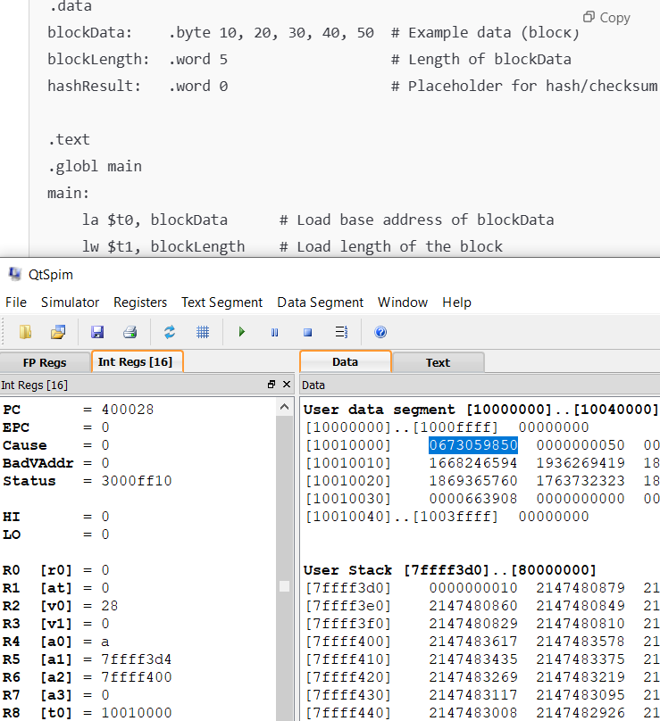

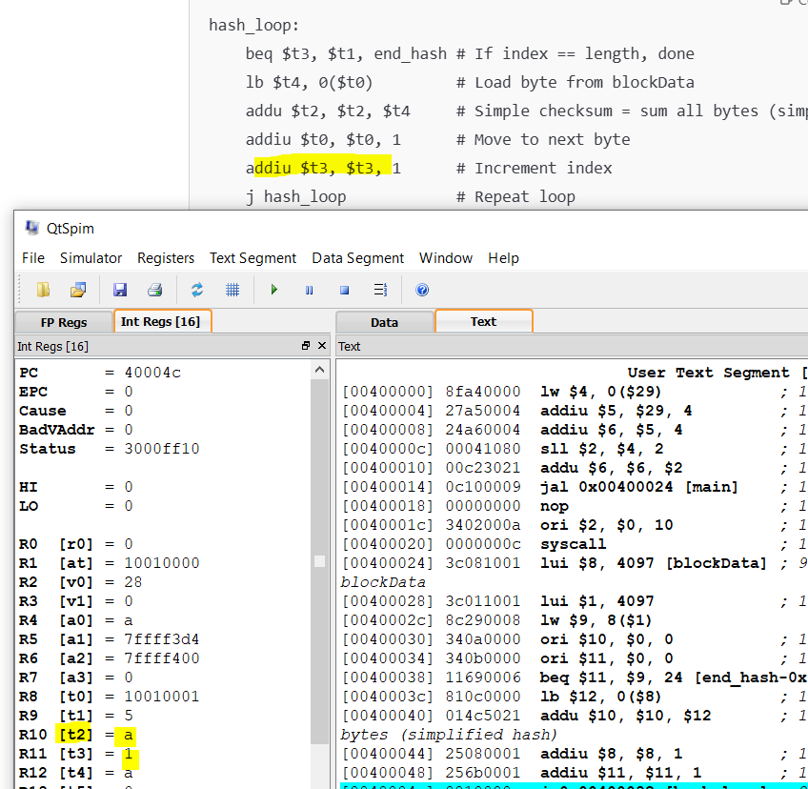

The second loop
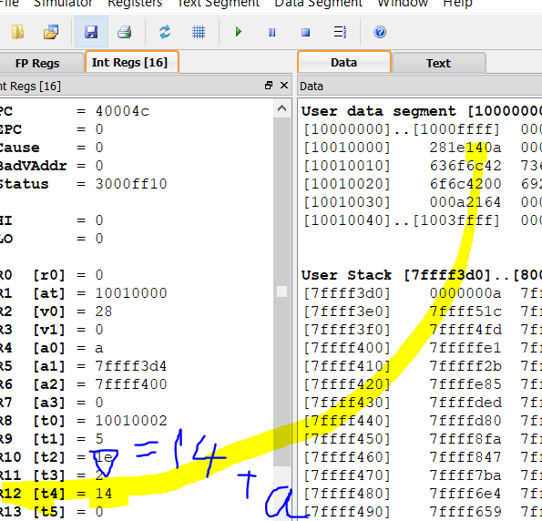

…
The final loop
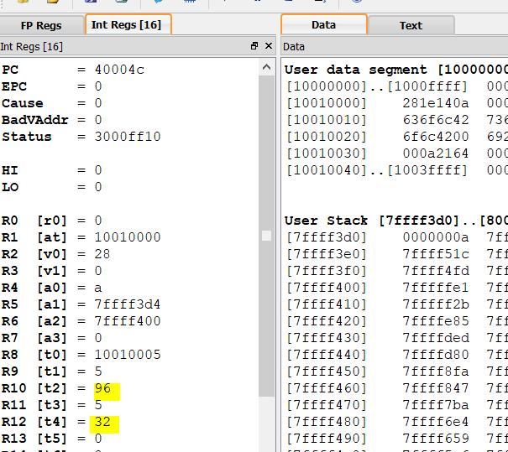

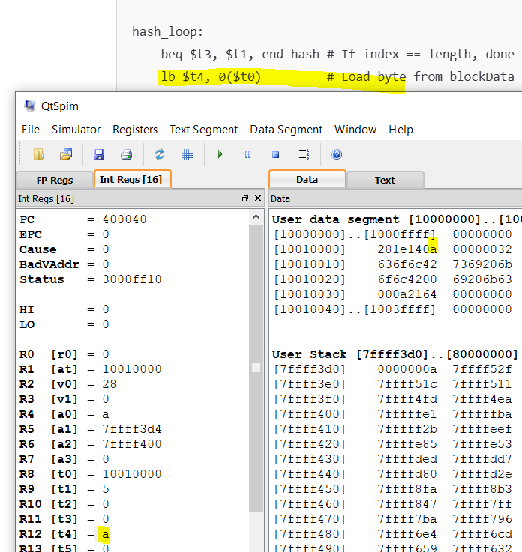

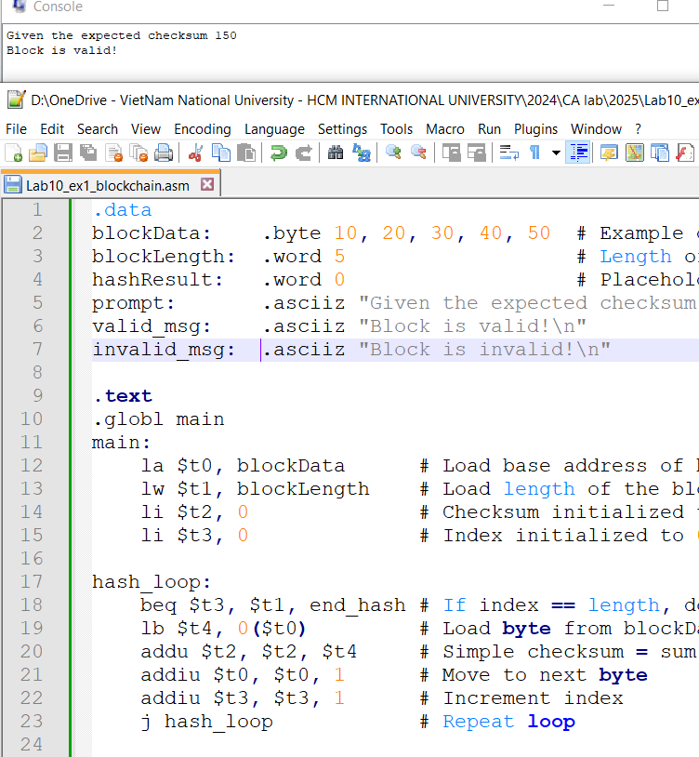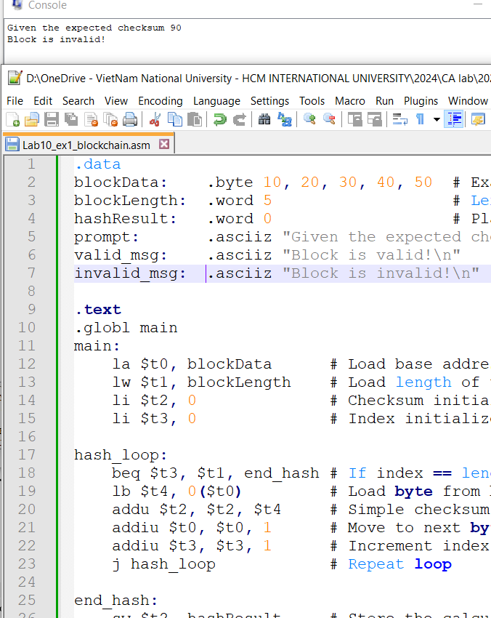
Questions of exam 1:
1. What is the content of the blockData array? How many elements does it contain?

2. What does the hash_loop do for each byte of blockData?

3. Where is the final checksum stored in memory?

4. How does the program store the user’s input checksum into a register?

5. What is the purpose of the comparison beq $s0, $s1, valid?

6. When does the program print "Block is valid!" and when does it print "Block is invalid!"?

Example 2: MIPS emoji blockchain simulation (with hash linking and simple verification)

🎯 Objective (Teaching Goals)
By the end of this lesson, students will be able to:
- Understand how to represent emoji characters using UTF-8 bytes in MIPS.
- Simulate a simplified blockchain where each block links to the previous block via a computed hash.
- Implement a basic hashing mechanism (e.g., summing bytes) in MIPS.
- Verify the integrity of chained blocks by recomputing and comparing hashes.
- Understand the limitations of emoji display and UTF-8 in MIPS simulators (MARS, QtSPIM).
✅ Pseudocode Explanation
Block0:  Set prev_hash = 0 (genesis block)  Load emoji bytes into memory (😀 in UTF-8: F0 9F 98 80)  Compute hash0 = sum(prev_hash + emoji bytes)  Store hash0 into block0_hash  Block1:  Set block1_prev = block0_hash  Load emoji bytes into memory (💍 in UTF-8: F0 9F 92 8D)  Compute hash1 = sum(block1_prev + emoji bytes)  Store hash1 into block1_hash  Verification (optional):  Check if block1_prev == block0_hash  If yes → blockchain is valid  Else → block is invalid (tampered)  END | - Stores an emoji encoded in UTF-8 format (e.g., 😀 = 0xF0 0x9F 0x98 0x80).  - Calculates a hash by summing:  - All emoji bytes  - The hash of the previous block  - Links blocks together by:  - Writing the hash of one block into the prev_hash field of the next block  - Validates blockchain integrity by:  - Recomputing hashes  - Checking that the prev_hash of each block equals the actual hash of the previous block

❓ Guided Questions for Students
Part A: Data Representation
- What is the UTF-8 byte sequence of the 😀 emoji?
- Why do we use .byte instead of .asciiz to store emoji data in MIPS?
Part B: Hashing and Linking
- How is the block's hash computed in the program?
- What role does block1_prev play in this blockchain structure?
- What would happen if someone changed the emoji data in block0 after hash0 was computed?
Part C: Simulator Limitations
- Why doesn’t MARS or QtSpim display the actual emoji when printed?
- How could a programmer still validate that the correct emoji bytes were loaded?

🔗 Real-World Analogy
- Similar to real blockchain (like Bitcoin or Ethereum), where each block contains:
  - A reference to the previous block (previous hash)
  - A data payload
  - A hash of the block’s contents
- If any data changes, the hash will no longer match, making tampering detectable.

💡 Key Educational Concepts
- Memory layout and la, lw, lb usage in MIPS
- Loops for summing bytes and computing hashes
- Hash chaining logic (block N depends on block N−1)
- UTF-8 encoding of emojis in .byte
- ASCII vs Unicode limitations in MIPS simulators (MARS, QtSpim)

Exercise 1:
Extend the example 2 by adding a third block containing the emoji

.
Encode it in UTF-8, compute its hash as:
hash = sum(prev_hash + emoji_bytes)
Link it to block1 by copying block1_hash into block2_prev.
Then verify the link by comparing values.

Exercise 2:
MIPS emoji blockchain problem using a simulated linked list structure,
✅ Goal:
Implement a linked list of blocks in MIPS, where:
- Each block contains:
  - Pointer to the next block
  - Pointer to the previous block
  - Emoji data (UTF-8 encoded)
  - A computed hash
- The hash is calculated as a sum of bytes + previous hash
- The program can traverse the list and validate the hash chain
- Input emoji that given in Exercise 1

